‘To foster a culture of compassion’

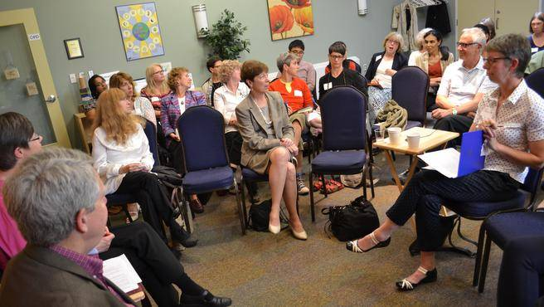
Kim MacAulay and Jim Torbert (left) invited representatives of various Halifax sectors interested in their Charter for Compassion toolkit to share what compassion means to them. (Chris Muise)
There’s always room for a little more compassion in the world, and one non-profit organization has developed a tool kit to ensure that compassion reaches every corner of the Halifax community.
Founded in 2012 by Kim MacAulay and Jim Torbert, the Waves of Compassion Association is dedicated to fostering compassion within all sectors of Halifax life, including schools, health care, business and government.
“Compassion is the ability and willingness to stand in another’s shoes,” says MacAulay. “Our purpose is to intentionally work with diverse community sectors, to help foster a culture of compassion.”
“That also includes working with different sectors to help them develop their own Charters of Compassion, so that they can become chartered compassionate organizations,” adds Torbert. “The intent here is to work with all these sectors over a long-range plan, to have that start here locally, then expand to the province, then expand out to the region — ultimately, changing the conversation that we have.”
What does compassion mean to these various sectors? For some, it might mean creating a safe and inclusive environment, both publically and privately. For others, it might mean something as simple as being more understanding of an individual’s needs in the workplace.
Each organization is going to approach the idea of compassion differently, in order to suit their individual needs and concerns, big and small. The challenge is to get all these organizations on the same sort of compassion operating system, as it were.
“We have a lot of initiatives that are very far-reaching, and very different and unique to all of the aspects of our populations,” says Paul Whyte, president of Mount Saint Vincent University’s Student Union. “Our racialized students, our aboriginal students, our queer folk... up until now, it’s been really tricky to figure out how we organize all of that so that we can be in solidarity for making more equitable governance.”
To that end, the Waves of Compassion Association recently held a seminar, inviting representatives from all the different sectors in HRM, and unveiled a brand-new toolkit that can help any organization develop a template for their own Charter of Compassion.
“It explains, and goes through the details, of how you plan, develop, and implement a charter of compassion,” says Torbert. “That charter itself, it lends a sense of discipline to developing compassion, rather than just making a light-handed commitment to it. It really forces you to contemplate, ’what does compassion mean?’”
The hope is that, by encouraging and helping Halifax organizations to develop a Charter of Compassion, they will encourage more organizations to make a strong commitment to actually implementing a policy of compassion, and sticking to it. They also hope their toolkit will help develop a common underlying language of compassion, so as to create a network of compassionate organizations, rather than just isolated institutions.
One of the early adopters of the charter is the MSVU Student Union, which is focusing on ways in which to make their student body feel more included and safe, and to make sure that the union can be held accountable for it’s promise of compassion.
“I really like this document, and I’m hoping to be part of the planning for this in the future,” says Whyte, who is personally interested in starting feminist collectives, addressing the gap between Canadian and International Students on campus, and fighting the Blood Ban for gay men. “When organizations are actively pursuing compassion, you’re actively pursuing human rights.”
Other sectors with representatives in attendance that made strong declarations to espouse and follow this tool kit included the Halifax Regional School Board, and Halifax Regional Municipality.
“I think the climate is right now for us to have those conversations around, ’what do we need to do differently,’” says Marlene Ruck Simmonds, SchoolPlus Leader for the Halifax Regional School Board. “It’s a prime opportunity, I think, to become reflective, but also action-oriented.”
“There are lots of things that are challenging around being compassionate and opening ourselves, and I look forward to this continuing engagement,” says Coun. Jennifer Watts, who represented the mayor at the unveiling.
Torbert and MacAulay are excited to see what happens going forward, and are happy to help any organization construct their charter. But they stress that they’re not constructing compassion itself within these organizations — they’re just helping to solidify what’s already there.
“First and foremost, it’s recognizing that compassion is inherent in everyone. In these organizations, it’s there, existing — we’re just uncovering it,” says Torbert. “It’s been happening, it’s currently happening, and here’s our plan to actually emphasize this more going forward.”
To find out more about how you or your organization can develop your own Charter for Compassion, visit the Waves of Compassion Association’s website, www.wavesofcompassion.ca.

About the Author
Chris Muise | Herald Community
chrismnmuise@gmail.com

